CRM Dashboard
in dashboard
all stages are not meaningful beacuse it already shown
insted we can make warm leads
cold leads
Hot Leads
Rotation ( Optional )
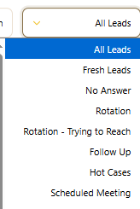
then in this we have these two icons (no meaning)
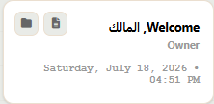 | 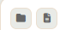
then + is for adding new lead
 | 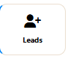 | 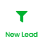
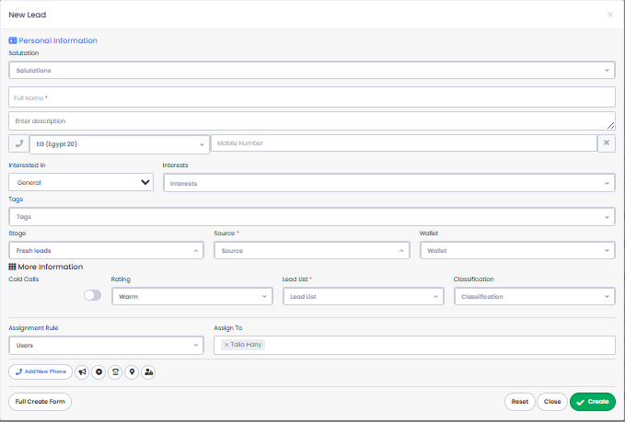
we need this form for one lead Creation
then we can Add one icon for bulk
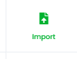

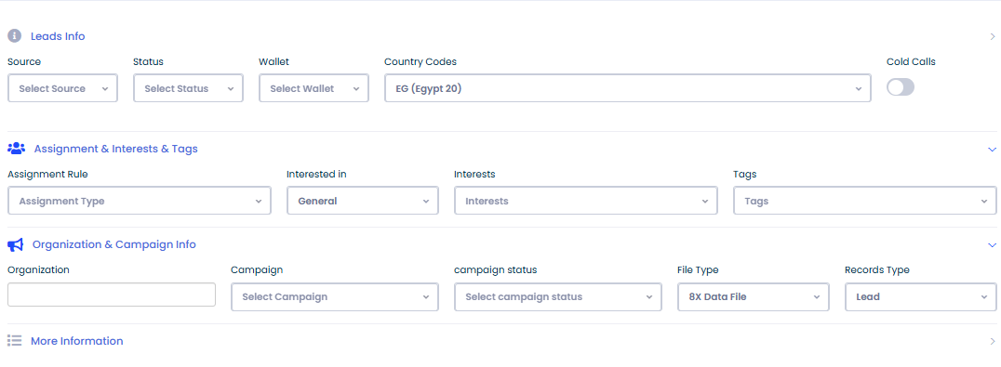
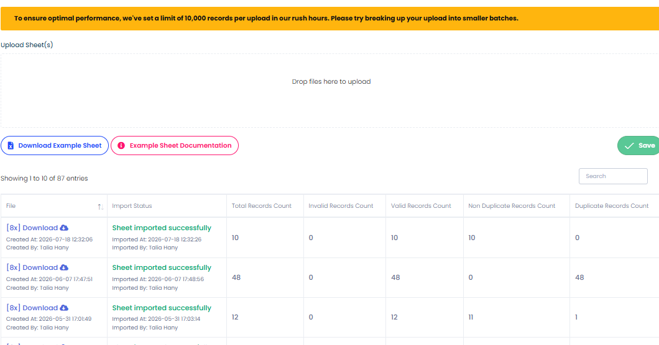
Downolad examples sheet - leads to excel sheet with this row to put all data one time and upload on crm
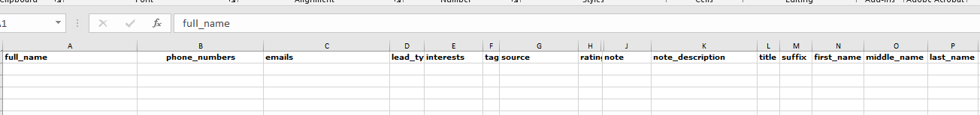
1- Creation Date , Activity Date , Assignment Date
its two ways ( Date Or Range ( From : TO ) )
2-
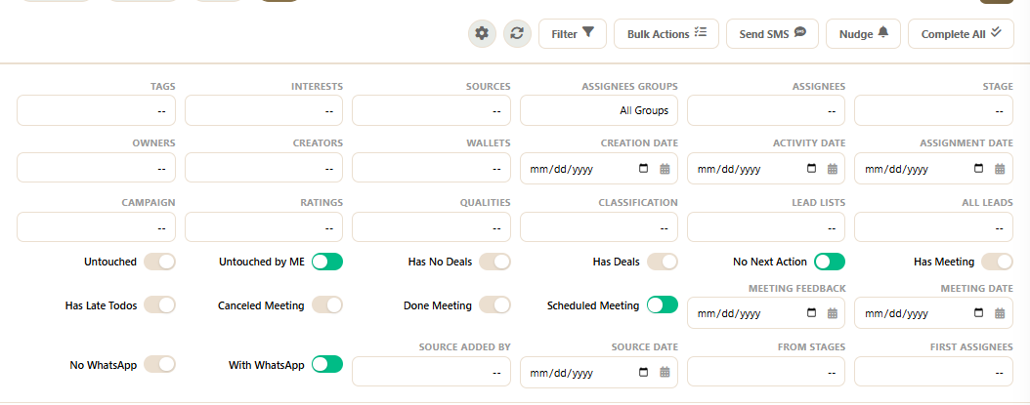
This is filters
The Advanced filters area


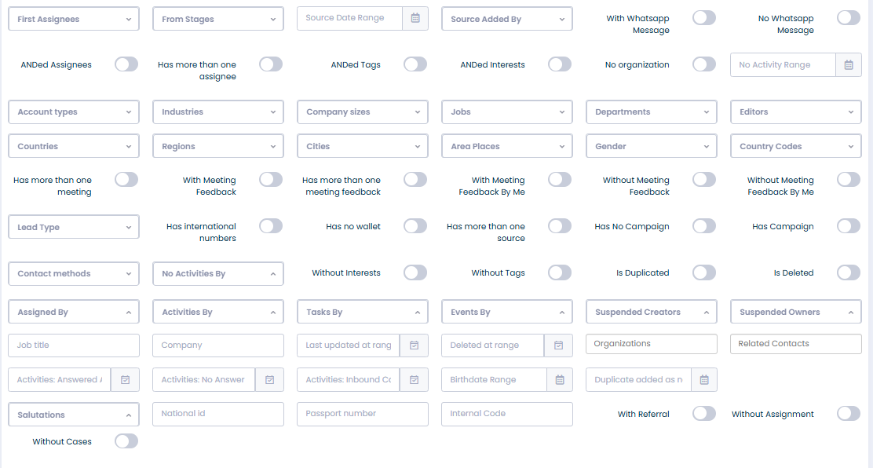
we also need to add assign from ( Agent x )
3 - Lead ID ( Code)
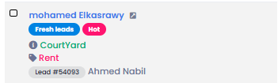 | 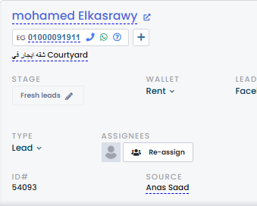
4 - why its obligated to select one
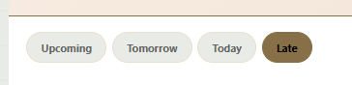
5- select Range
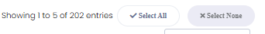
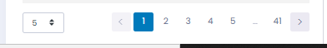
here its either all or none
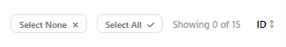
6-Bulk Actions , Not working
7- mark all Complete we wanna Add
Deffered ( For Operations Actions)
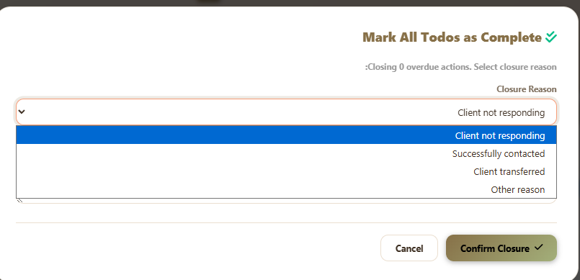
8- whatever filters chosen Action can not be done
9- these are outo Selected
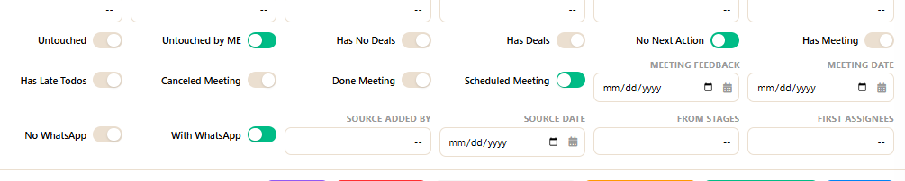
10 Nudge isnt working brdo
11- Exports
all of them is the same
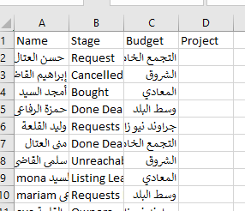
Bulk Actioms
another is the undo action
we can do a history for bulk Actions where we can undo it
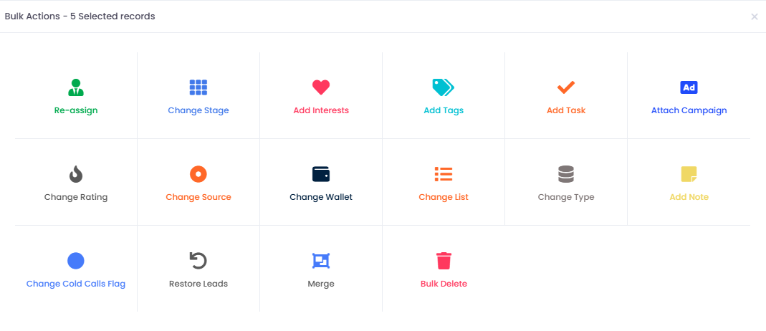
1 Reassign
Re-assign to anothe Agent
hide history
change stage
+ the one we wanna do ( Mark all todos as Complete)
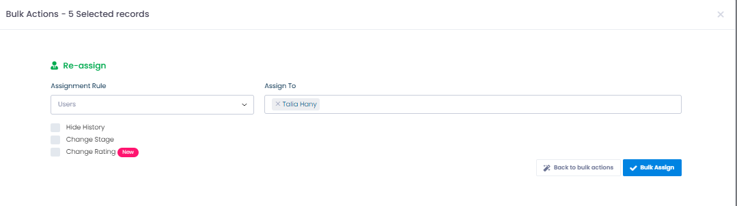
2- Change stage
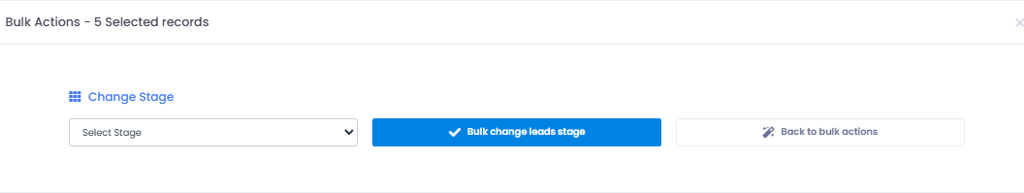
3- Change stage
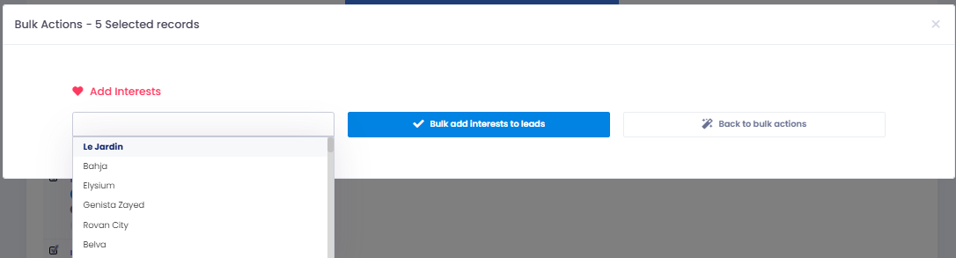
4- Tags
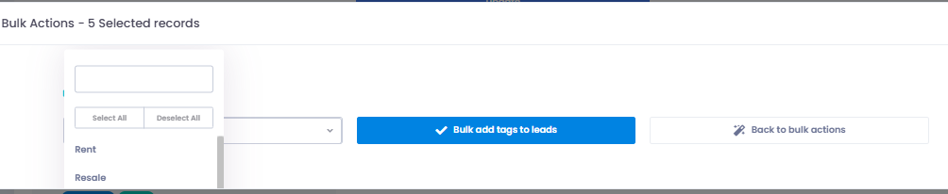
5- Add Tasks
where we can select a number of leads to make a new task on it so agent can be reminded to take action or follow up
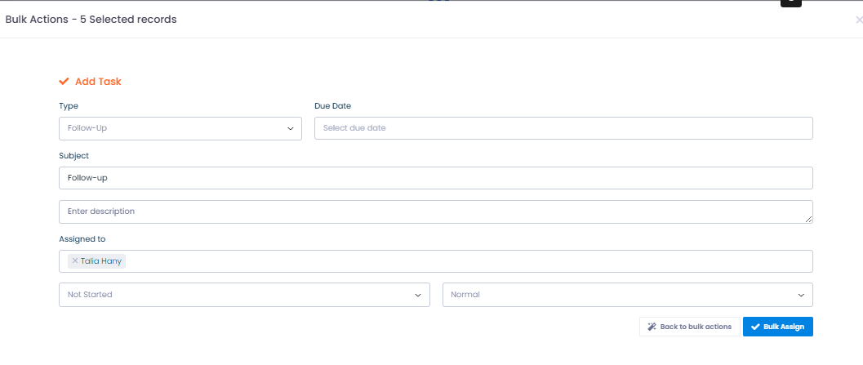
also we might as well add a bulk nudge or notification action ( New Version )
where we can select a number of leads make bulk Nudge and it appers as a task or follow up to make agent take action on lead
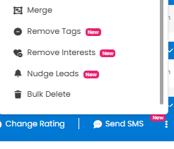
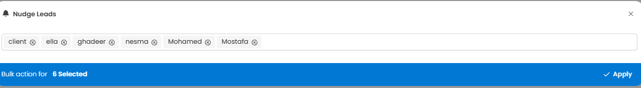
6- Add Campaign
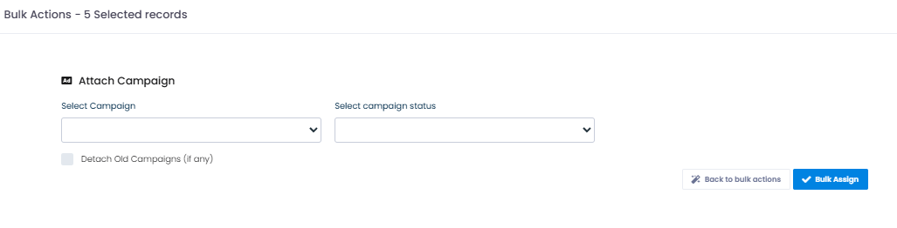
7- Change Rating ( Warm- Hot - cold )
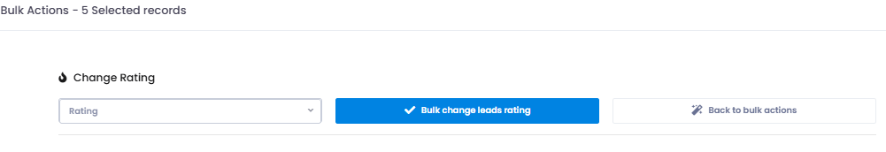
8-Change source
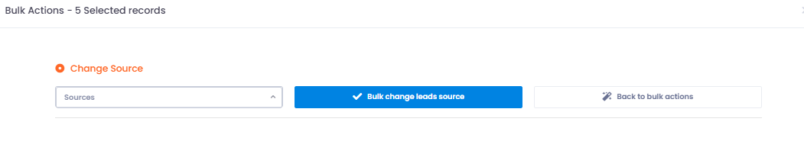
9- Change wallet
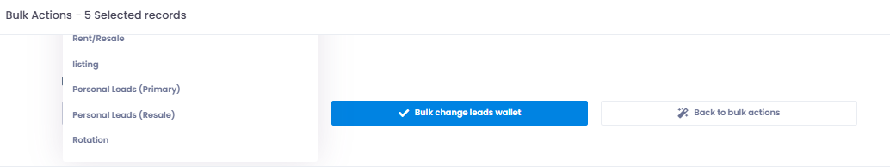
10 - Add bulk Note
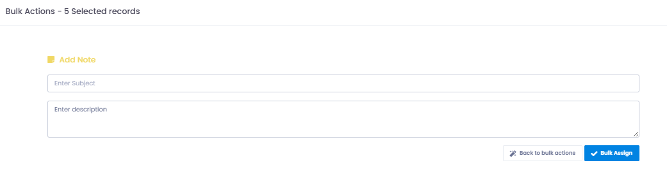
11- Merge leads
Rarely done as a bulk
For dublicated leads
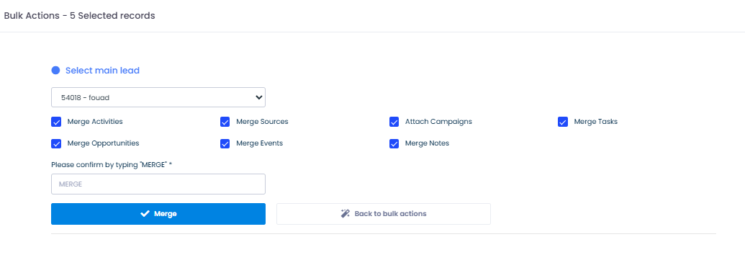
12- Bulk Delete
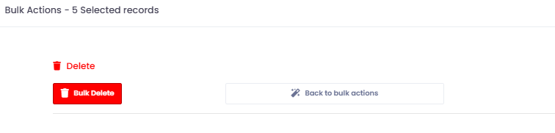

Deals
these are not working
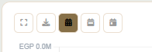
3- Deals Icons
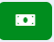

it will direct you to
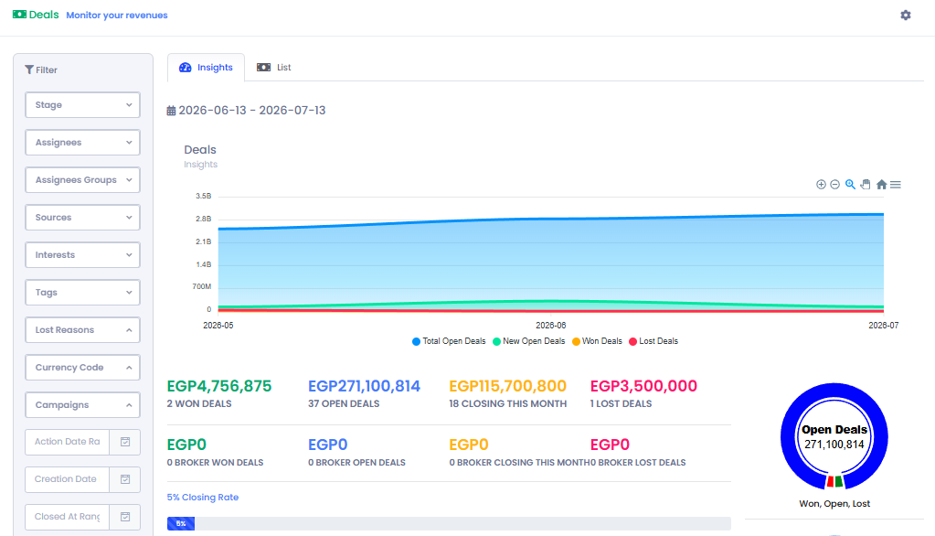
insights for our deals
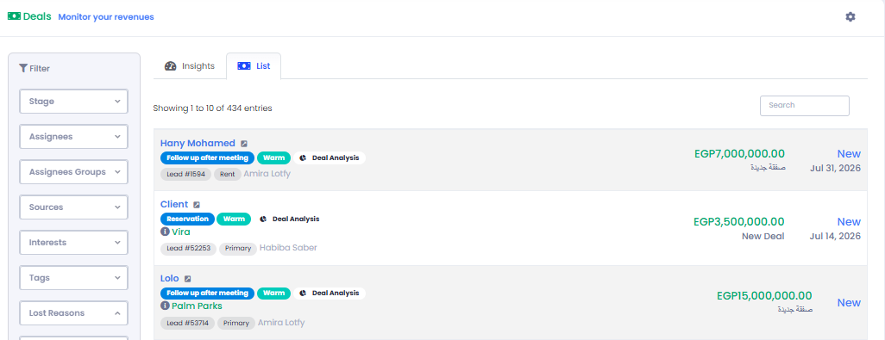
lists for every new deal Action Made by agent and Its lead
Filters where it helps us into reports or searching for a lead or analysis
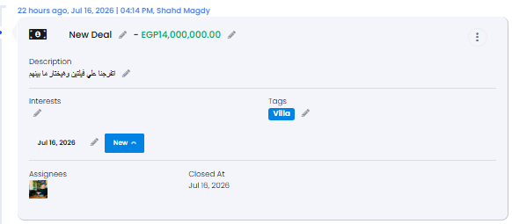 | 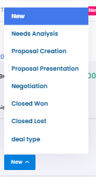
we need to add bulk action to close old deals to close the action
Closed lost or won
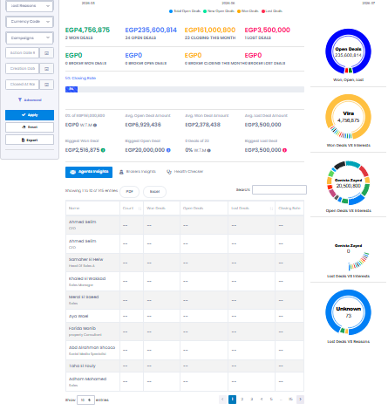
then in the list
i need to direct me to the lead
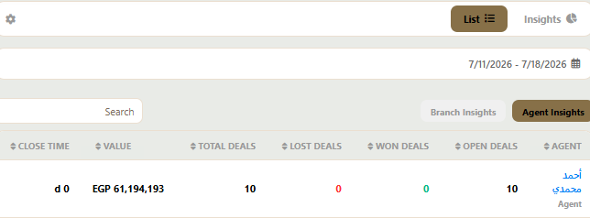
when i click on ahmed it shows nothing
plus seetings does not direct me to anything
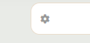
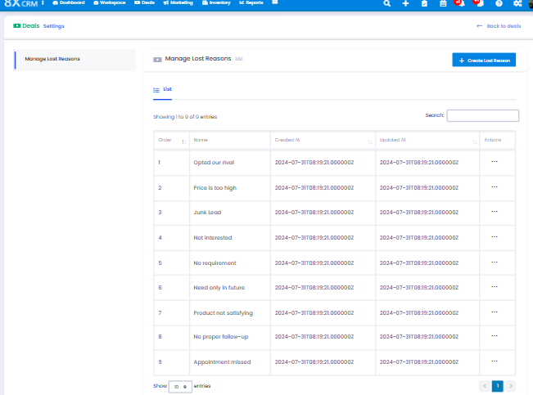
Marketing
5 - Markrting
 | 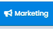
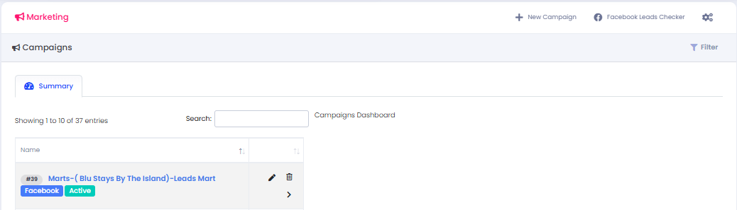
we will find all acampaigns
Search Bar
Filters
+ New Campaign “
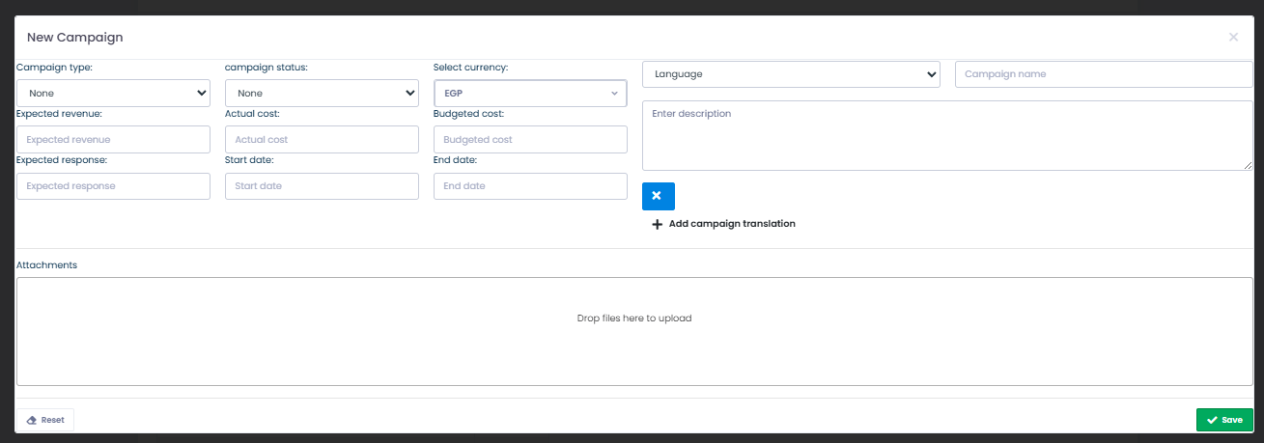
Inventory
4- INVENTORY


these two icons will direct us to our inventory
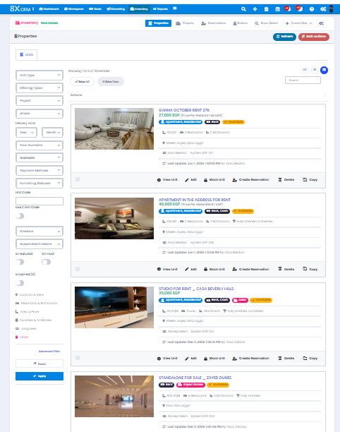
First
unit details
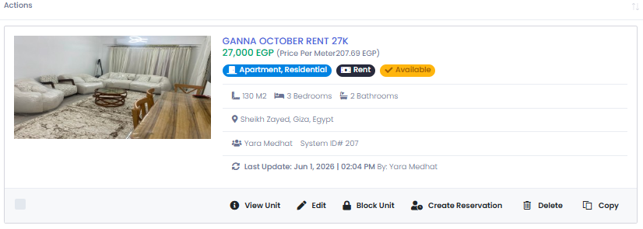
when clicked on
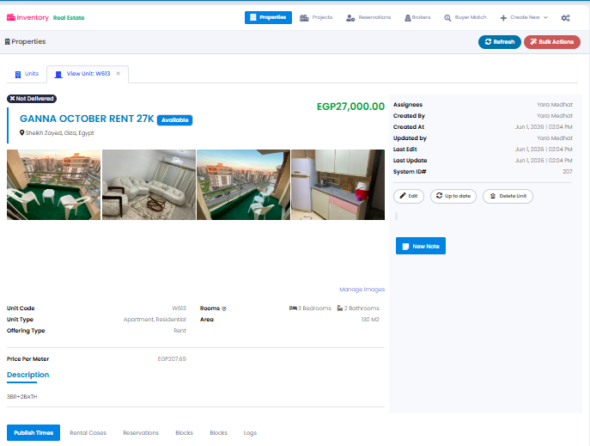
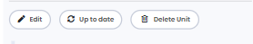

here we can edit - update and delete
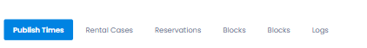
publish time is the most important or most usable from here
CReate Publish time
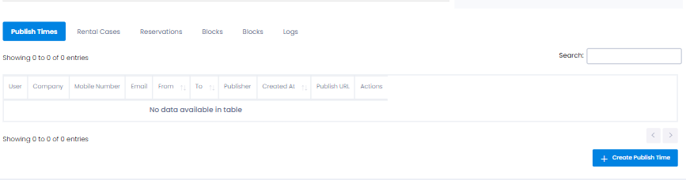
when we chose all details it creates a publish link
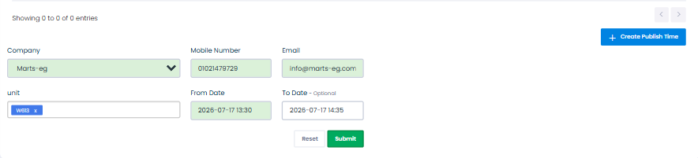
publish URL
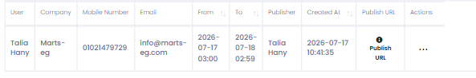
we cand dend it to client or we can post it on facebook to genertae leads from get in touch
client will type his info and will be direct on crm
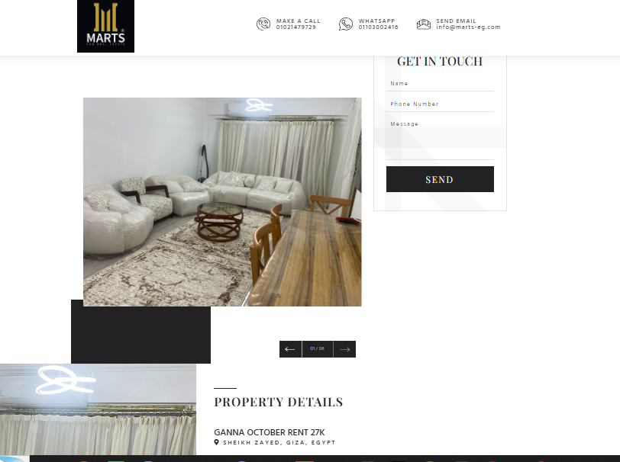
then how to add unit
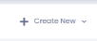 | 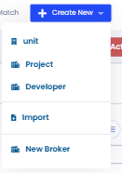
select unit
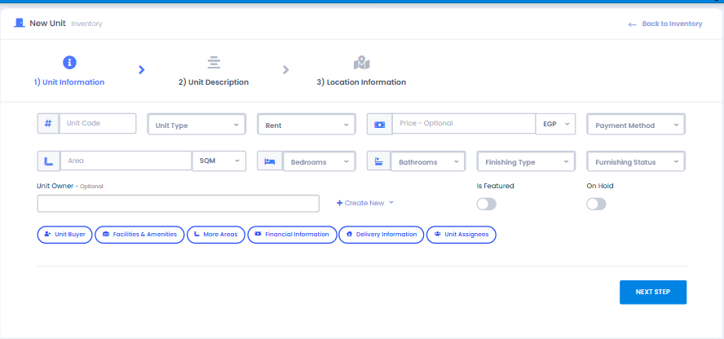
then fill info
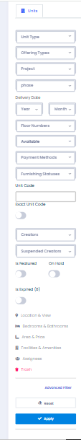
here we cand search by filters for any unit
icons only , doesn’t direct me to any thing
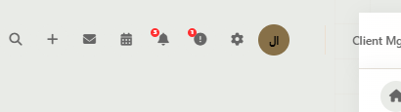
search is only valid by phone number

